Hominins

- Hominins have the ability to stand upright with bipedal locomotion, and they also tend to have; a large brain and less hair

The Hominin fossil record

- Most of the evidence we have of our early ancestry comes from fossils; these fossils are very rare and often comprise of no more than a few broken fragments of heavily mineralised bone, or a few teeth; very occasionally an almost complete skeleton or skull is discovered, but this is very unusual
- Recognising our evolutionary history is like trying to piece together a jigsaw puzzle with many of the pieces missing; without a clear idea of the picture, we can only infer how the puzzle might fit together
- To date the total amount of fossil material discovered could be loaded into a small truck; knowledge of our possible ancestry has been further aided by the study of DNA
- Slowly, the puzzle takes shape; however, the picture is still far from complete and reconstructing our evolutionary history still remains one of the most challenging and controversial areas of science

Why did bipedalism develop?

- Where Hominins first appeared in East Africa, there was a change in the climate and it became much cooler and drier
- This lead to a change in the vegetation from dense forest to open woodland and savannah; food in a savannah environment is different and more spread out than in a forest
- As a result, Hominin ancestors must have had to expand their diet to include a greater variety of foods found on the ground (bulbs, grains, roots), therefore they were forced to travel further from their home base to gather food

What is the advantage in being bipedal?

- Bipedalism is an energy efficient means of covering large distances to collect food
- It leaves the hands free to carry food, tools, weapons and young
- Hominins stand taller so they have greater vision to spot food and/or danger
- Standing taller also increases ability to reach food
- It allows an individual to appear larger which deters predators
- Less surface area is facing the sun in hot, dry environments so they do not heat up as much
- Body higher from ground minimises heat gain from the ground

- Given efficient bipedal locomotion, good eyesight, a smart brain and free hands, early bipeds (Hominins) had a better chance of surviving in a very challenging savannah environment than quadrupeds (non-Hominins)

Hominin ancestors

- Apes and humans share a common ancestor, an ape-like creature, and from that ancestral ape the first hominins (modern and extinct humans) evolved
- These were the Australopithecines classified in the genus Australopithecus
- It is believed that one or more of the australopithecine species evolved early member of the genus Homo
- Species of early Homo gradually evolved into a number of different species, including Homo habilis, Homo erectus and Homo neanderthalensis, and eventually into modern humans, Homo sapiens

- Australopithecus afarensis (4 to 3 mya)
- Australopithecus africanus (3.3 to 2.5 mya)
- Paranthropus robustus (2.3 to 1 mya)
- Homo habilis (2.3 to 1.8 mya)
- Homo erectus (1.9 mya to 50,000 ya)
- Homo neanderthalensis (350,000 to 25,000 ya)
- Homo sapiens (195,000 ya to present)

Australopithecus and Paranthropus

- The Australopithecines were thought to be the first Hominins (Southern Africa)
- There were two forms, gracile and robust; the gracile forms were smaller and lighter and the robust were heavier
- This lead to a reclassification, with the two gracile forms being;
  - Australopithecus afarensis
  - Australopithecus africanus
- The robust form being;
  - Paranthropus robustus
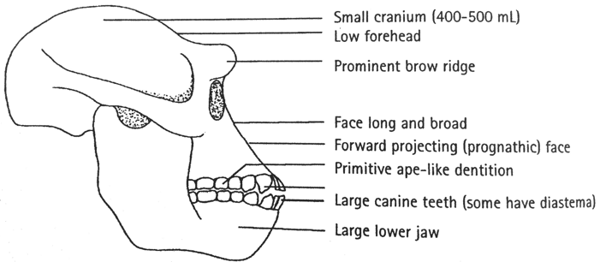
Australopithecus afarensis
Geographical location | East Africa (Ethiopia, Tanzania)
Time period | 4 to 3 million years
Cranial capacity | Avg. 430cm³ (small)
Height | 1 to 1.5m (short)
Weight | 30 to 55kg (light)
Skull/jaw | Small cranial capacity, large brow ridges, low forehead, flared zygomatic arch
Jaw | Prognathic jaw, large canines, diastema
Locomotion | Bipedal; central foramen magnum, all post cranial adaptations to bipedalism (spine, pelvis, femur, knee, foot)
Culture | Not required
Australopithecus africanus
Geographical location | Southern Africa
Time period | 3.3 to 2.5 million years
Cranial capacity | Avg. 430cm³ (small)
Height | 1.1 to 1.4m (short)
Weight | 30 to 55kg (light)
Skull/jaw | Small cranial capacity, reduced brow ridges, low forehead, flared zygomatic arch
Jaw | Prognathic jaw, smaller canines, slightly more modern teeth (smaller)
Locomotion | Bipedal; central foramen magnum, all post cranial adaptations to bipedalism (spine, pelvis, femur, knee, foot)
Culture | Not required
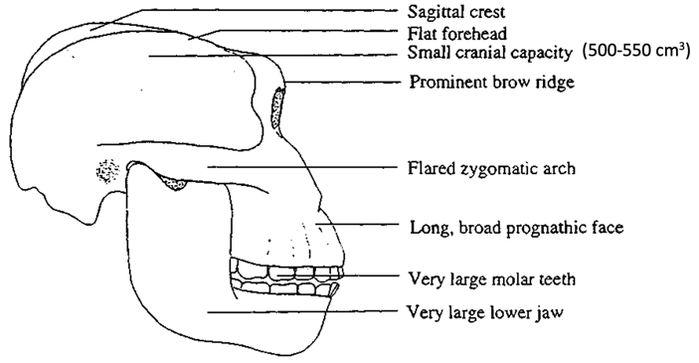
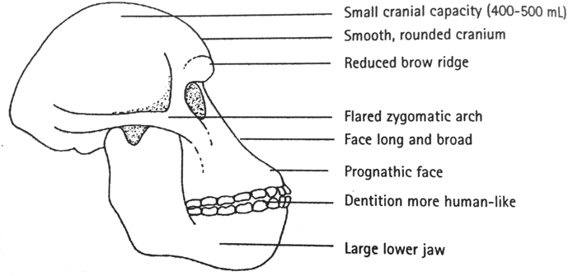
Paranthropus robustus
Geographical location | Southern and East Africa
Time period | 2.3 to 1 million years
Cranial capacity | Avg. 520cm³ (small)
Height | 1.1 to 1.4m (short)
Weight | 40 to 80kg (heavier)
Skull/jaw | Very robust, sagittal crest, brow ridges, low forehead, flared zygomatic arch
Jaw | Massive jaw, prognathic, smaller canines, large molars
Locomotion | Bipedal; central foramen magnum, all post cranial adaptations to bipedalism (spine, pelvis, femur, knee, foot)
Culture | Not required

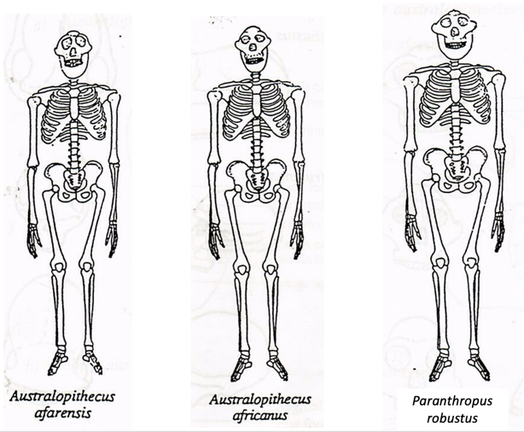

Homo habilis
Alternative name | Handy man
Geographical location | Southern and East Africa
Time period | 2.3 to 1.8 million years
Cranial capacity | 600 to 800cm³ (average 700cm³)
Height | Avg. 157cm (males), 125cm (females)
Weight | Avg. 52kg (males), 32kg (females)
Skull/Jaw | Larger brain, smaller jaw, smaller teeth and flatter face than Australopithecines; still prognathic brow ridges compared to sapiens
Culture | Made and used simple stone tools (Oldowan) with primary flakes  Used tools as cutters and scrapers  Some possible hunting, mainly scavengers
Diet | Omnivores, increased meat and marrow in diet (key difference) (meat and fats required for larger brain)
Other | Large family groups had food sharing and division of labour  Temporary shelters  Daytime gathering food, night time in trees  Robust hands  Enlarged speech area of brain (Broca’s), therefore simple sounds/speech
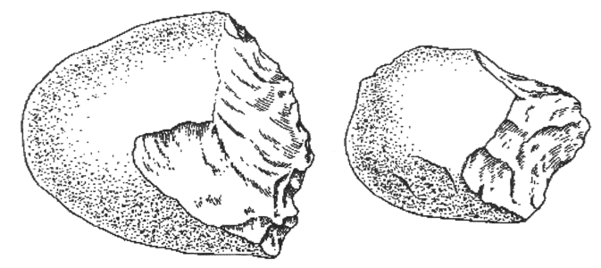
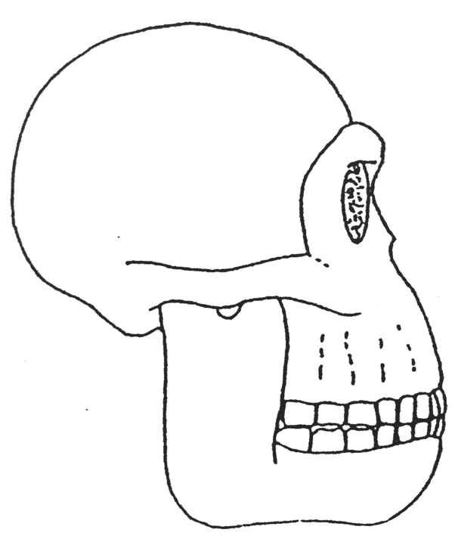
Homo erectus
Alternative name | Java man, Peking man, upright man
Geographical location | Africa, Europe, Asia (thought to be first of Africa)
Time period | 1.8 million years to 50,000 years
Cranial capacity | 850cm³ to 1150cm³ (average 1000cm³)
Height | Avg. 180cm
Weight | Avg. 54kg
Skull/Jaw | Heavy brow ridges, thick skull, low flat forehead, heavy chinless jaw, prognathic upper jaw, smaller more modern teeth, occipital bun, central foramen magnum  Larger brain  Less prognathic than habilis  Larger Broca’s area (speech)
Culture | First to use fire for cooking (more nutrition, kills parasites), warmth, protection and light, allowed migration  Made and used more complex pebble (stone) tools with (secondary flaking) hand axes (Acheulean)  Cooperative hunting for larger animals (tools found with bones at butchers sites) which suggest complex language for communication (Broca’s area)  Division of labour (women gathered nuts, fruits, roots and berries and men did the hunting)  Constructed living seasonal sites and lived in caves increased use of home bases  Modification of environment to suit own purposes
Diet | Omnivores
Other | Possible cannibalism  Robust post cranial skeleton  Less body hair  Possible migration due to population pressure
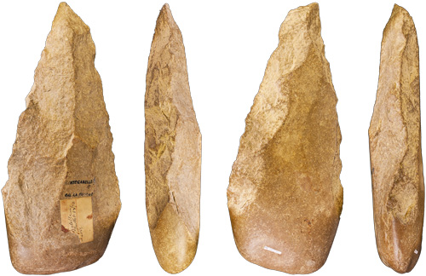
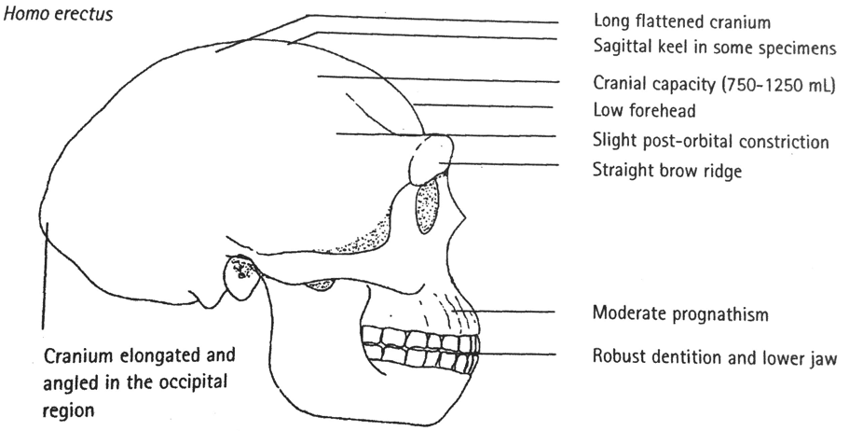

Homo neanderthalensis
Alternative name | Neanderthal man
Geographical location | Europe and Middle East
Time period | 200,000 to 30,000 years
Cranial capacity | 1500cm³ average
Height | 150cm
Weight | 70kg
Skull/Jaw | Long low cranium, sloping forehead, reduced brow ridges and large occipital bun, no chin, large nose, modern teeth, slight prognathism
Culture | Complex pebble (stone) tools with tertiary flaking, wood and stone tools combined (spears) – Mousterian tool culture  Cooperative hunting of large game (mammoths/bison) with butchering and transfer of meat  Complex language  Division of labour  Wore simple clothing (animal skins) for protection against cold  Increased reliance on home base and fire for warmth, cooking, light and protection  Abstract thinkers  Evidence of religious rituals with burials of dead (bear cult)  Care of sick and disabled  Possible cannibalism
Diet | Omnivores
Other | Large nose moistened and heated cold air (adaptations to cold)  Very stocky, very heavily built; muscular, short limbs, barrel chested (adaptations to cold)
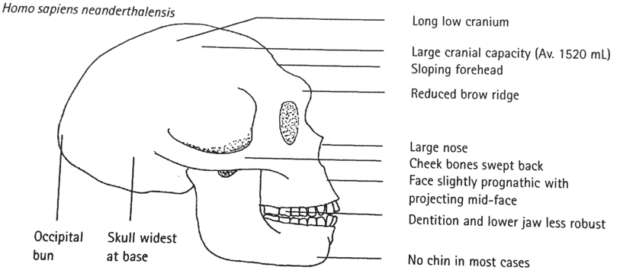
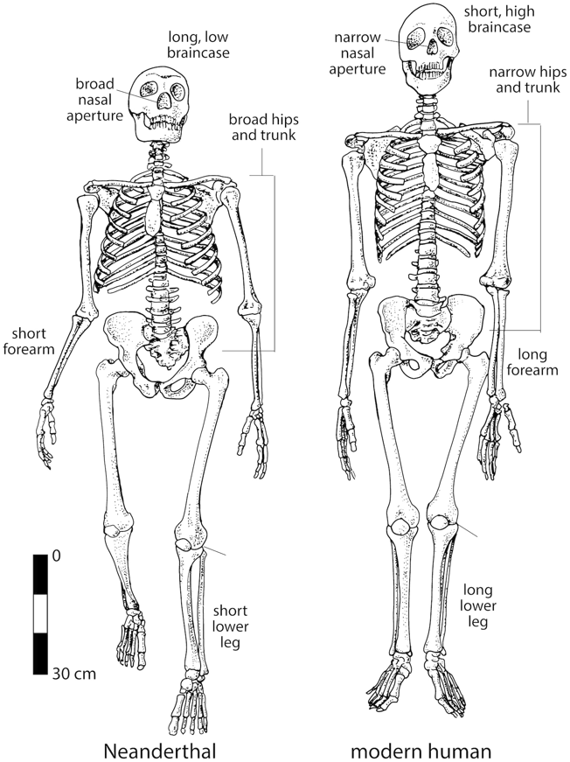

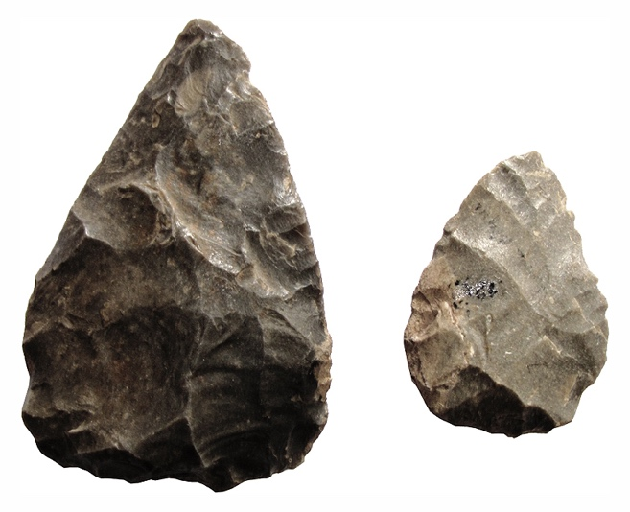

Homo sapiens
Alternative name | Humans
Geographical location | Worldwide
Time period | 100,000 years to present
Cranial capacity | 1350cm³ average
Height | 180cm
Weight | 80cm
Skull/Jaw | Chin, high vertical forehead, slight brow ridges, unspecialised small teeth, small jaw, rounded, smooth cranium, same as our skull; lightweight, flatter face
Culture | Build more elaborate complex permanent shelters  More elaborate clothing (sewing)  More advanced, complex tools including use of bone, horn, and ivory to make needles, hooks and harpoons (hafting combination of wooden and stone tools)  Visual art; cave paintings, bone carvings and clay statues, jewellery  Fishing with nets  Belief in life after dead
Other | Taller and slightly more built than Neanderthals
